Installation Development Project Documentation

Daniel Taylor

Jake Burton

Winson Tao

Yamil Tarabin

Available at: [GitHub Release](https://github.com/Daniel-Luke-Taylor/Installation-Development-Project/releases/tag/1.0)

Demonstration at: [Prototype Video](https://drive.google.com/open?id=1Y8H00pvV_kOKPruEqJIzgvLQkkqwZNnR)

Table of Contents

Concept 3

Vision 3

Ideation 3

Designs 4

Wave Machine designs (old) 4

Blueprints 5

Table Tennis Ball Designs (Final) 5

Blueprint for laser cutting 6

Equipment List: 7

Container 7

Container Requirements: 7

Dimensions 7

Arduino 7

Actuators 7

Sensors 8

Paddle 8

Table Tennis Ball 8

Construction Materials 8

A Computer 8

Technical Architecture 9

APIs, IDEs, Libraries and SDKs Required 9

Kinect for Windows SDK 2.0 9

Arduino IDE 9

Firmata 9

Processing 10

Arduino Firmata (processing library) 10

KinectPV2 10

Prototypes 11

Making Waves 11

Materials used: 11

Propeller: 12

Paddles: 13

Ultra-Sonic Range Sensor prototype 15

Final Prototype 17

Final Product 18

Meeting Minutes 20

References 27

# Concept

The concept is to take the hand movement and gestures of the user and give it a physical output.

## Vision

Our vision is to take the hand movements of the user and translate them into the movements of the paddles, there will be a Table Tennis ball at the bottom of the tank guided by curved rails. The paddles will move and hit the ball and it will move from left to right and right to left.

The previous idea of the project was to take the hand movements of the user and translate them into waves in a body of water, although the main concept, which is to take the hand movement of the user and translate it into the movement of the project is still there, due to lack of materials (specifically linear servo motors) we as a group had to change the idea of how to realise the main concept, after deliberation we decided to remove the body of water as the motors available would not produce the desired effect on the water.

# Ideation

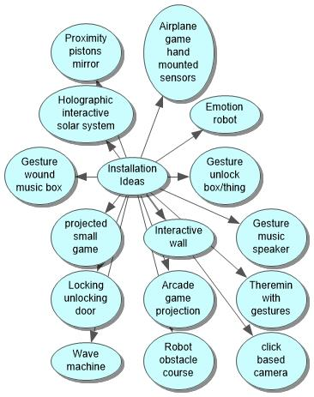

Figure - Mind map showing possible project ideas

# Designs

### Wave Machine designs (old)

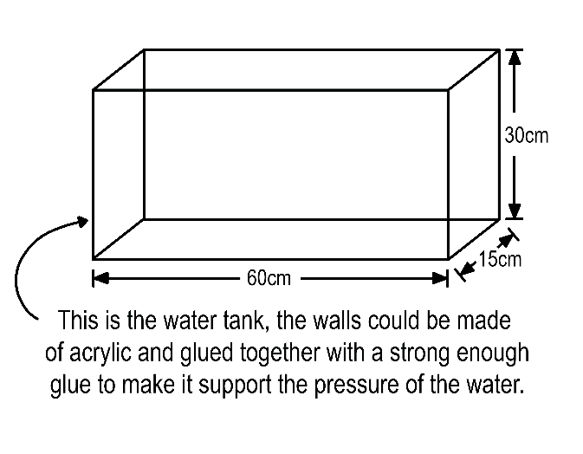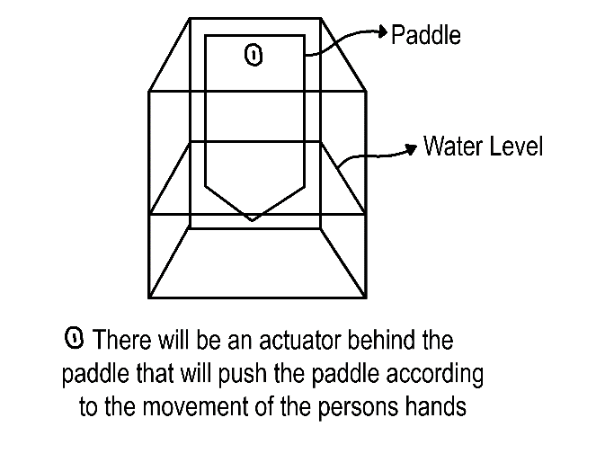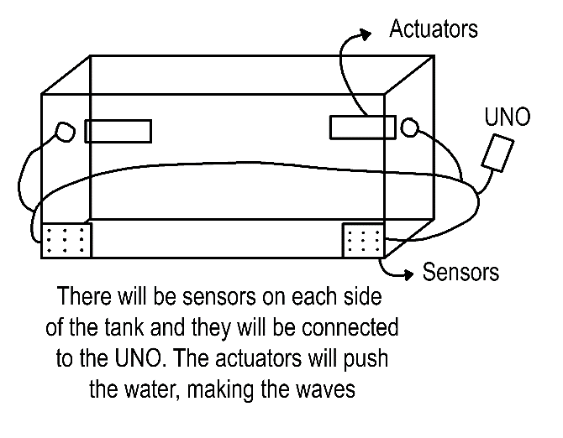

Figure - Old project designs

# Blueprints

## Table Tennis Ball Designs (Final)

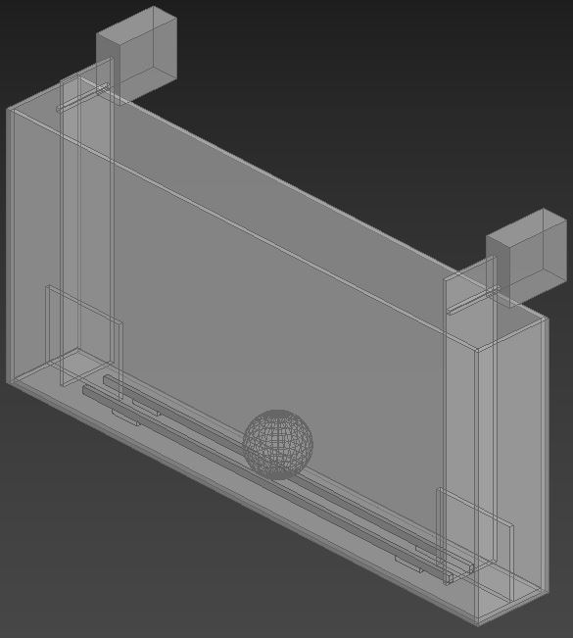

56mm

380mm

180mm

Ball

Rails

Paddles

Stoppers

Servos

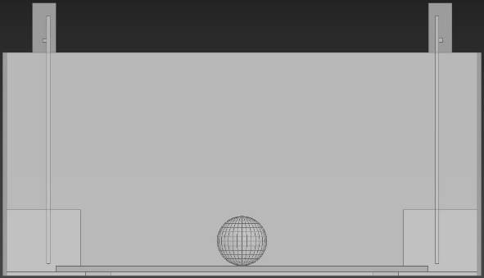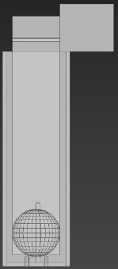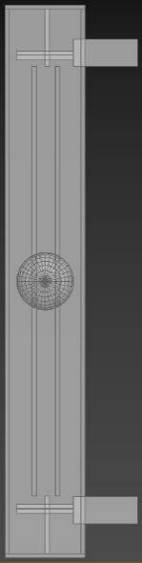

Front View

Top View

Side View

Figure - 3D rendition of project output

## Blueprint for laser cutting



Front

Back

Base

Right

Left

Paddles

Stoppers

Rails (not final changed in laser cutter)

Figure - Illustrator file used to laser cut container parts

# Equipment List:

## Container

The project revolves around using gestures to manipulate a ping pong ball. Using a container will keep the ping pong ball in an environment where it can be manipulated by servos, and so that the ping pong ball won’t leave the workable space.

### Container Requirements:

* **Square or Rectangular Shaped Plastic Tank** – A square or rectangular shaped plastic tank will allow for easier manipulation over the ping pong ball when it is being pushed in a single direction. A circular or round plastic tank has more space for the ping pong ball to move around, that can bounce around towards the edges making it more difficult to control with servos.
* **Plastic Tank Size** – The plastic tank must have enough room to fit in equipment such as the paddles and actuators along with the ping pong ball itself. There also must be enough room for the paddle to swing the ping pong ball to either side.
* **Plastic Tank with an Open Top –** An open top plastic tank will enable equipment such as paddles and actuators to be fitted inside the plastic tank.
* **The Plastic Container will be Custom Made** – By creating a new container from scratch, the container can be shaped into the ideal size needed to carry out the concept. The container will be laser cut from a sheet of transparent acrylic from a workshop located at the University of Greenwich, Stockwell Street Library.

## Dimensions

The Acrylic used has a thickness of 3 mm.

* Height: 180 mm (Doesn’t take the motors into account)
* Width: 56 mm
* Length: 380 mm

## Arduino

The Arduino is another essential component for the artefact to function. The Arduino is a cheaper alternative to the raspberry pi, with another advantage being a larger source of innate power available to be used for external hardware. The Arduino will be used to control the servos.

## Actuators

An angular servo will be used to swing a paddle, which will hit the ping pong ball and make it roll to meet another paddle on the other side of the tank that is attached to a servo.

## Sensors

Xbox One Kinect Camera Sensor – This sensor will be used to track the user’s hands and will be able output a number based on the horizontal distance of the hands. This will be the ideal user experience and is the first choice for input.

Xbox One Kinect Camera Sensor PC Adapter - The Kinect sensors that were available for students to borrow and use for their projects, had a cable connection that could only connect to the Xbox One games console. Therefore, a console to PC cable adapter is needed to connect the Kinect to a computer so that the computer can interact with the Kinect.

## Paddle

A paddle is used to push the ping pong ball to either side of the plastic container. The paddle will be made from the same sheet of transparent acrylic that was use for the plastic container, because the paddle will become more durable, it would match the plastic container aesthetically, and it was because there was enough material to create the paddles.

Other alternatives would have been card or cardboard because they are relatively cheap to acquire and they are very malleable, which can give more options to attach the paddle to the servo.

## Table Tennis Ball

The table tennis ball is the object of interaction and so it is needed for the art installation to work.

## Construction Materials

Using construction materials, they will be used to assemble the plastic container from the components cut out from a laser cutter. The construction materials that will be used are:

* Duck-tape
* Blue tac
* Plastic Weld
* Pop-sickle sticks

The plastic weld will be used to weld the plastic components together to form the container that will hold the servos, paddle, and the ping pong ball. The duck-tape, blue tac and the pop sickle sticks will be used to support and attach the servos to the plastic container. The duck-tape will also be used to mark out the lines where the user should stand during the demonstration.

## A Computer

A computer is needed to run the processing program and the kinetic sensor. It will also be used to program the source code for the artefact.

# Technical Architecture

The user will be able to wave their hands in front of a Kinect sensor and when the user moves their hands to the side the servo mounted paddle connected to the Arduino will fire and hit a ping pong ball.

The solution will start with using a Kinect sensor for input. This will be connected to a computer powerful enough to process the data from the sensor and get hand coordinates. The processed data will then be sent to an Arduino which will use that data to move the servos.

## APIs, IDEs, Libraries and SDKs Required

### Kinect for Windows SDK 2.0

(Microsoft Corporation, 2014)

Used to connect the Kinect device to a computer and access the data from the steam.

### Arduino IDE

(Free Software Foundation Inc, 2018)

IDE used to interface with the Arduino and provides the Firmata code for external programs to connect to the Arduino.

### Firmata

(Free Software Foundation Inc, 2018)

Library used so the Arduino can receive commands from external programs.

### Processing

(Fry & Reas, 2019)

IDE used as a connector for the Kinect and Arduino technology, and to provide a visualisation of the implementation for debug purposes.

### Arduino Firmata (processing library)

(Free Software Foundation Inc, 2018)

Library used to access the Arduino from inside of the processing sketch.

### KinectPV2

(Lengeling, 2016)

Library that can access and process the data from the Kinect sensor.

# Prototypes

## Making Waves

### Materials used:

ب 
فين.. «موووم..،ن لاب 
وو 
٢٠٠١) ن 

Figure – Resources for making waves prototype

* A large black rectangular shaped plastic container
* Transparent tape
* Rubber bands
* Craft sticks
* Card paper

The wave that needs to be created must be big, as the aim is to imitate as close as possible the motions of the hand. If the hand motion over the sensor is slow, the wave should also go slow; if the hand motion is fast, the wave motion should also be fast.

### Propeller:

The first prototype we made was a propeller, we used two craft sticks as the base and rubber bands to keep them together, the card paper was cut into a rectangular shape to then be attached to the craft sticks with tape.

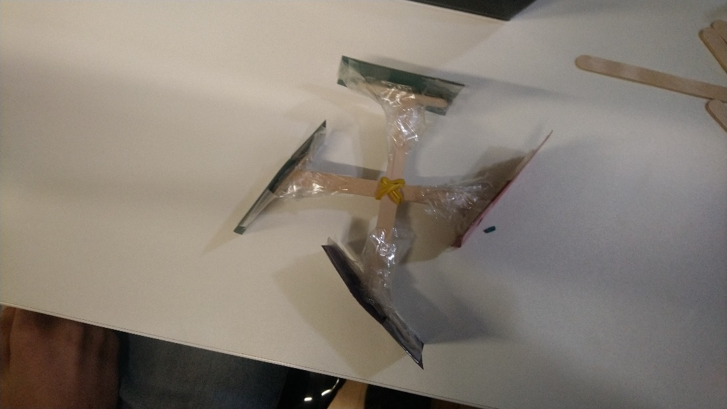

Figure – Constructed Propeller

With another pair of craft sticks, rubber bands and tape a rotational arm was made, the idea was that this would be attached to the motor and as it rotates the propeller would also rotate.

When the propeller was tested, we came to the realization that the type of waves created were not the desired type as the propeller made many small waves in a quick succession, while the desired waves were big and slow imitating the hand motions.

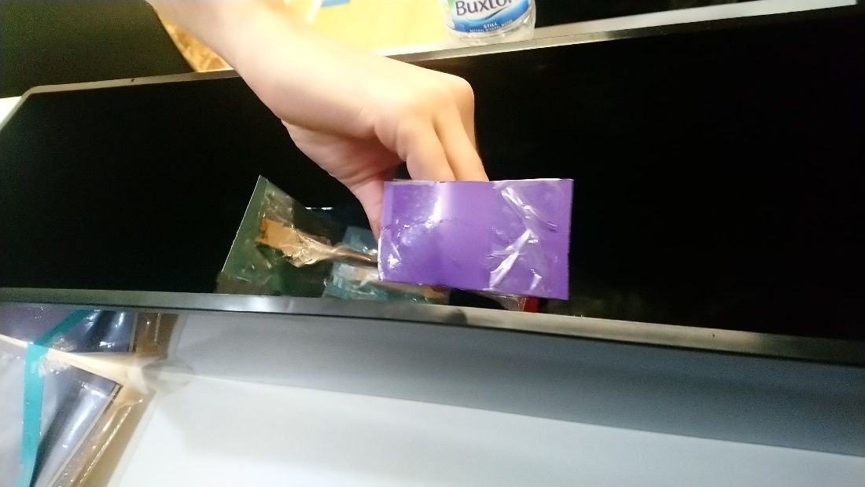

Figure - Propeller Testing

### Paddles:

The second prototype we made were a pair of paddles, to make them we used the card paper and drew the shape of the container, after cutting it we used craft sticks to strengthen the paddle to increase its firmness and with tape we completely wrapped it to make it resistant to water.

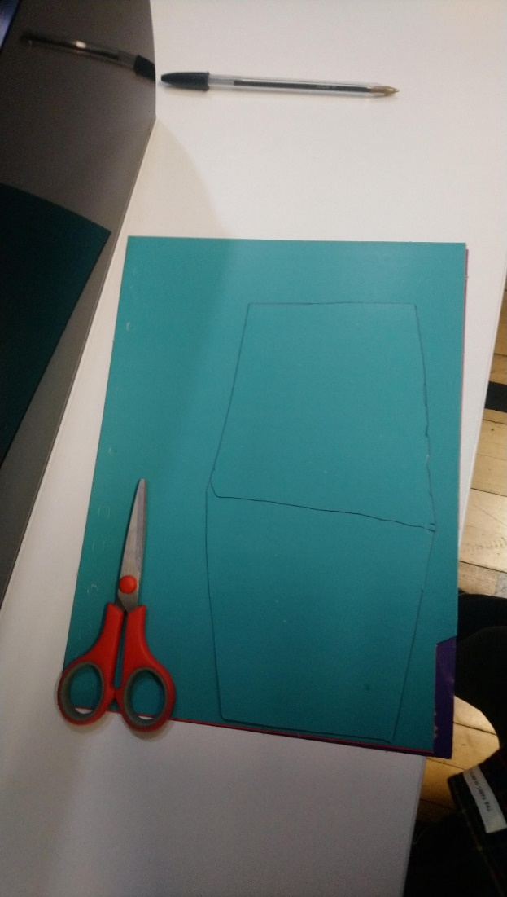

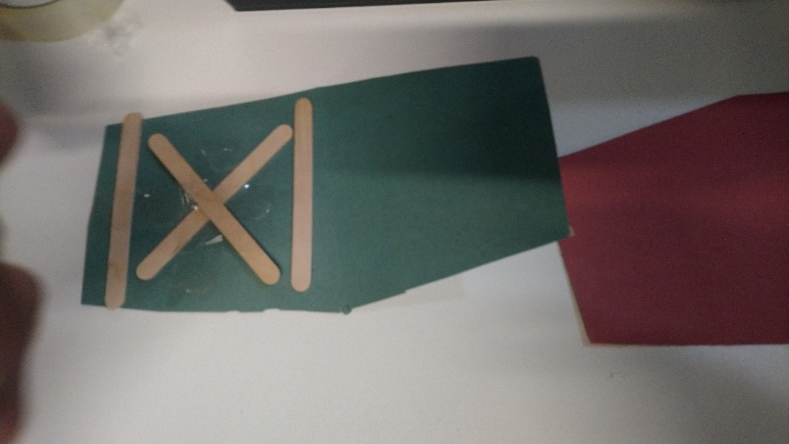

Figure – Images Showing Paddle Construction

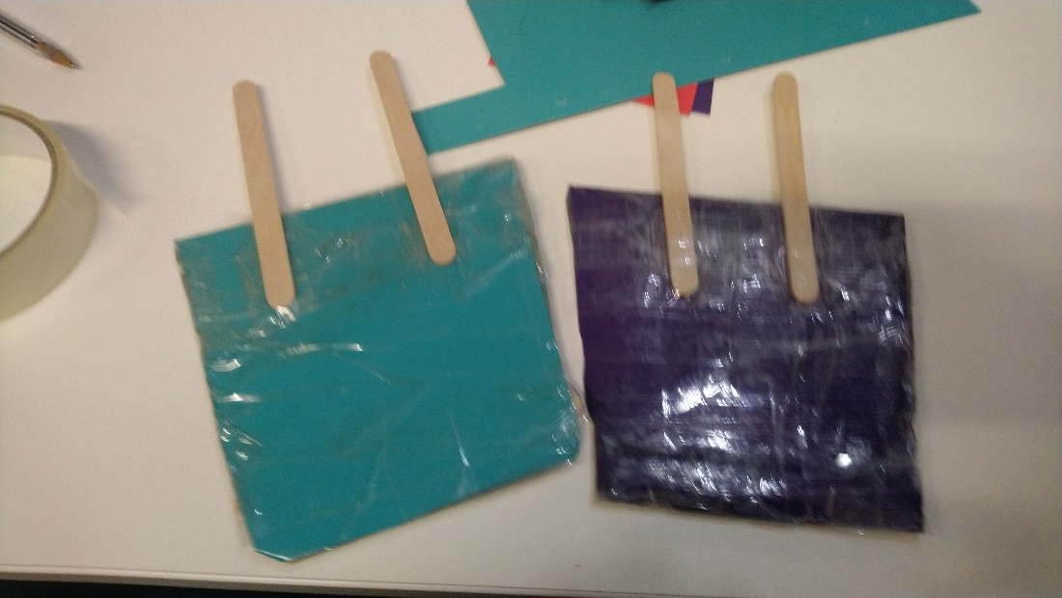

Figure - Constructed paddles

When the paddles were tested, we came to the realization that this is the way forward, the paddles created one big wave that move according to the motions of the hand

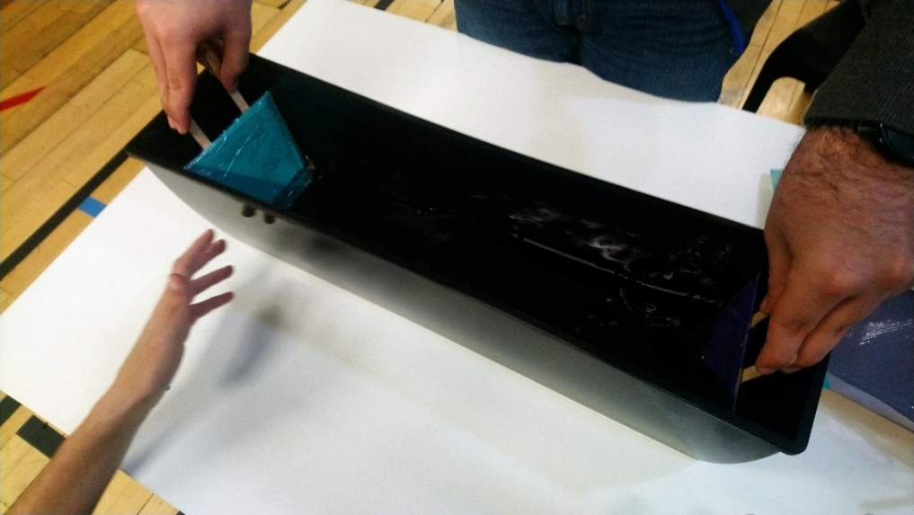

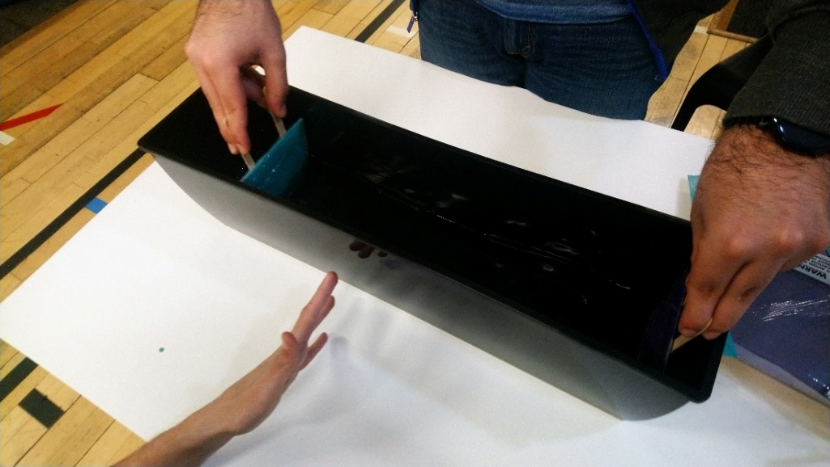

Figure – Images Showing Paddle in Use

## Ultra-Sonic Range Sensor prototype

In the search for the different methods of how a user could interact with Arduino using gestures, one such method was using an Ultra-Sonic Range sensor. To start the experiment, we had first borrowed equipment from the lab at King William which includes:

* A buzzer
* Wires
* One LED light
* Arduino
* Breadboard
* Computer system

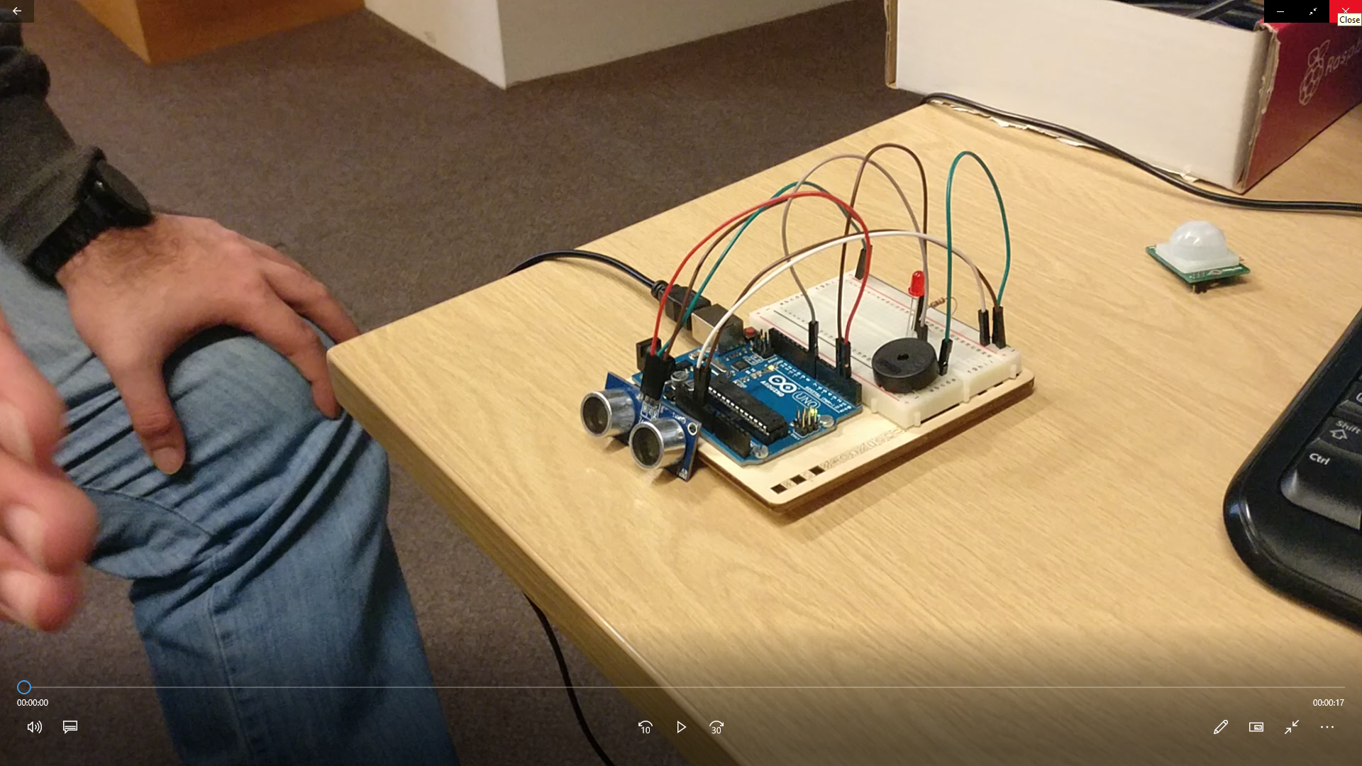

Figure USRS

The experiment was designed to test to see how the Ultra-Sonic sensor registers hand movement and how it could be used for the art installation. Using the source code provided by one of our team members Daniel, the pitch of the buzzer can be controlled using an Ultra-Sonic Sensor to create a Theremin. The distance between the sensor and the hand feeds back into the command console, which helps show that the sensor is working.

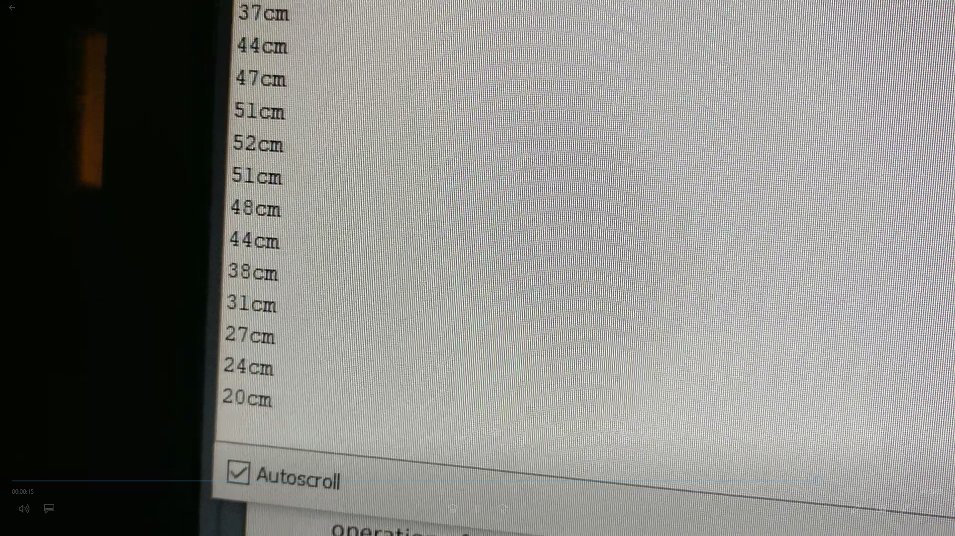

Figure Output of the USRS

We found that the Ultra-Sonic sensor could only sense movement along a linear path. The constraints that the Ultra-Sonic sensor had, made the Ultra-Sonic sensor a less preferred choice for our method of interaction as it did not meet the quality of user interaction that we desired. We decided to experiment with other methods of interaction such as the Kinect that would better suit our demands.

However, the Ultra-Sonic sensors were a good alternative to use in case we could not get the art installation to work with the Kinect.

## Final Prototype

Materials used:

* Duct Tape
* Acrylic
* Blu-Tac
* Craft Sticks
* Angular Servo
* Arduino UNO
* Xbox Kinect

The box was constructed using the acrylic that was cut and glued it together using plastic weld.

The origin point was located on the angular servos and the paddles were attached to the servos using Blu-tac and duct tape.

The servo was placed on top of the box, aligning the paddles with the stoppers and secured in place using Blu-tac, duct tape and craft sticks

The servo’s turn point was tested to secure the servos in place as the paddles moved.

The servos were calibrated to make sure the ball did not fall under the paddle.

The product was user tested for errors and resulting errors were dealt with.

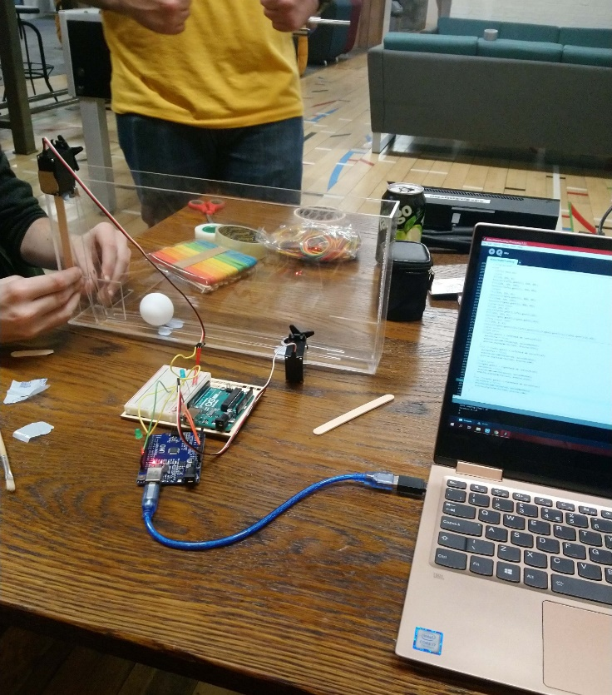

Figure 13 - Prototype Construction

The product was made and tested with no single player errors.

# Final Product

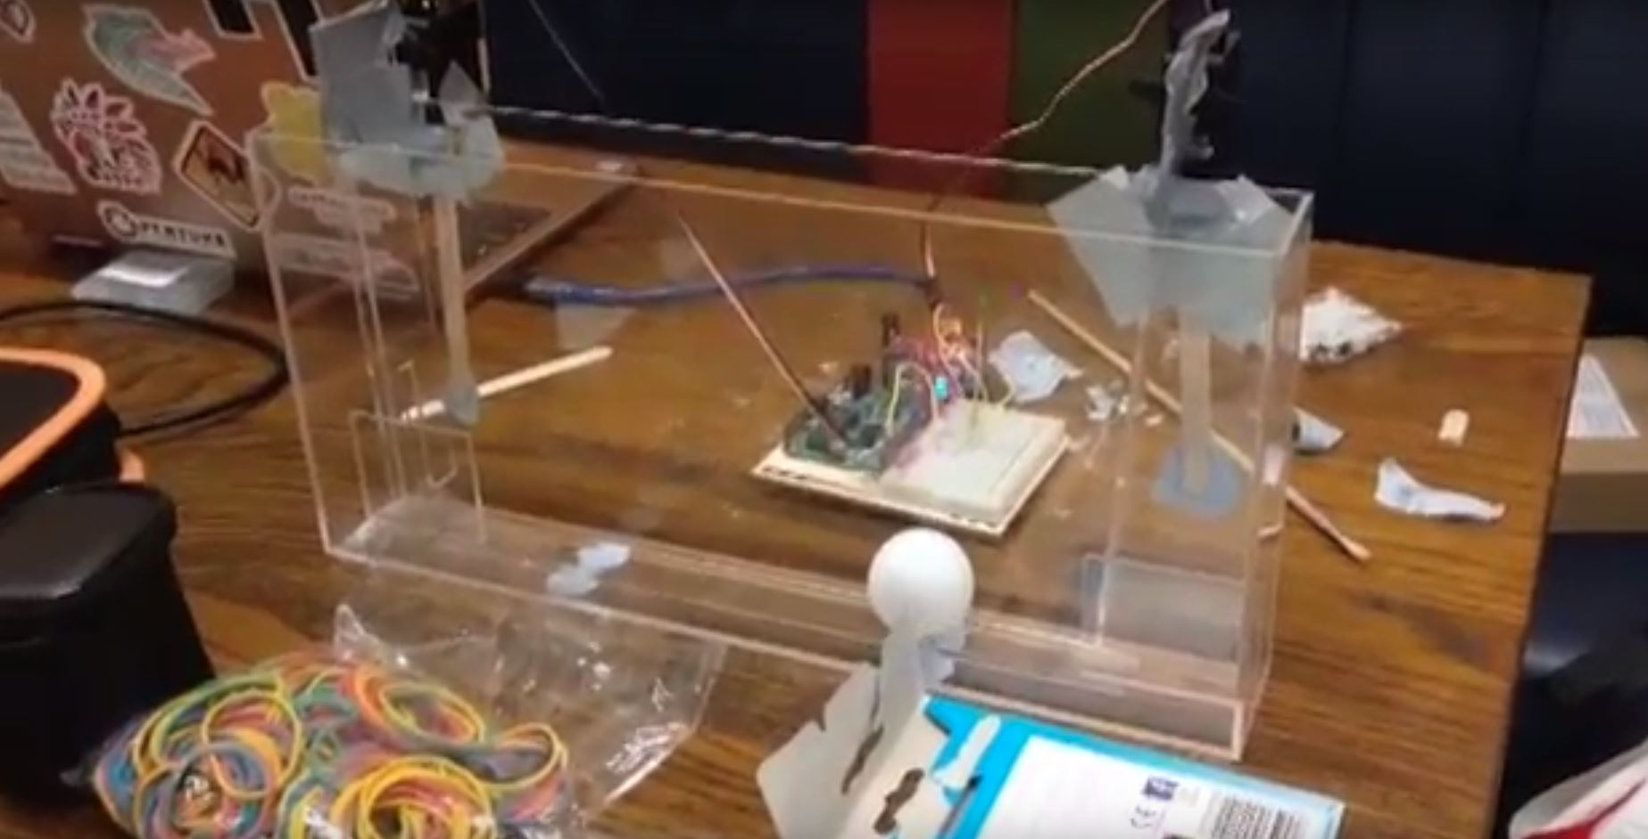

Figure Front of the Final Product

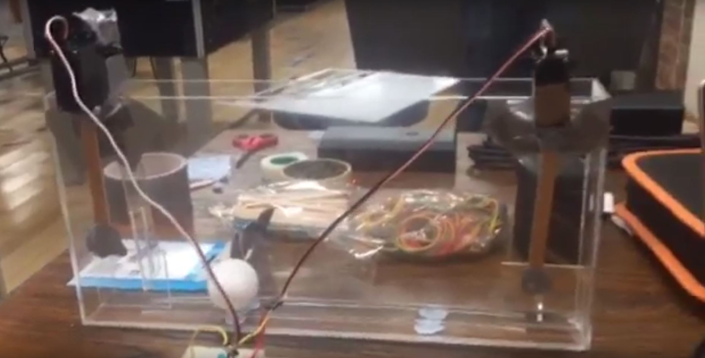

Figure Back of the Final Product

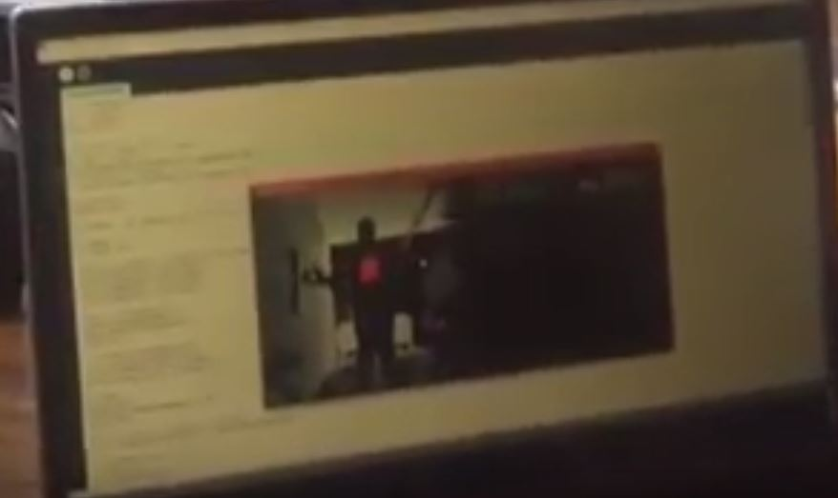

Figure Computer Visualization

GitHub Release: <https://github.com/Daniel-Luke-Taylor/Installation-Development-Project/releases/tag/1.0>

Prototype Demonstration Video: <https://drive.google.com/open?id=1Y8H00pvV_kOKPruEqJIzgvLQkkqwZNnR>

# **Meeting Minutes – Installation Development Project**

## **Meeting Information**

**Objective:** Discuss implications and solutions to not having access to a linear actuator for the project.

|  |  |
| --- | --- |
| Date: 21/03/2019 | Location: King William Computer Lab |
| Time: 17:00 | **Meeting Type:** Project rework |
| Called By: Daniel Taylor | **Facilitator:** Daniel Taylor |
| Time Keeper: Daniel Taylor | **Note Taker:** N/A |

**Attendees:**

* Winson Tao
* Daniel Taylor
* Jake Burton
* Yamil Tarabin

|  |
| --- |
| Agenda Items |
| Discuss implications and solutions to not having access to a linear actuator for the project. |

|  |
| --- |
| Decisions |
| Rework project to use a Table Tennis ball and paddle-based output rather than water and waves. |

|  |  |  |
| --- | --- | --- |
| New Action Items | Responsible | Due Date |
| Create new design drawings to accommodate the change. | Yamil Tarabin |  |
| Adjust and document changes to the project plan (Assets, concept etc) | Jake Burton, Winson Tao |  |
| Book out angular servos that will be used to power paddle movement. | Yamil Tarabin, Daniel Taylor, Jake Burton |  |
| Create and conduct a prototype experiment for the paddle action. | Jake Burton, Winson Tao |  |

|  |
| --- |
| Other Notes & Information |
| Meeting was called as an emergency meeting after learning that the project would not have access to any linear actuators (A requirement of the previous plan) |
|  |
|  |

# **Meeting Minutes – Installation Development Project**

## **Meeting Information**

**Objective:** Undergo testing with the angular servo motors

|  |  |
| --- | --- |
| Date: 19/03/2019 | Location: King William Computer Lab |
| Time: 5:00 pm | **Meeting Type:** Project Development |
| Called By: Daniel Taylor | **Facilitator:** Daniel Taylor |
| Time Keeper: Yamil Tarabin | **Note Taker:** N/A |

**Attendees:**

* Winson Tao
* Daniel Taylor
* Jake Burton
* Yamil Tarabin

|  |
| --- |
| Agenda Items |
| Undergo testing with the angular servo motors |
| Discuss the rail shape and size for the new project |
| Undergo testing and setup of the Kinect API and hardware |
| Redesign the blueprints of the container to fit the new requirements |

|  |
| --- |
| Decisions |
| Changed the size of the container to make it shorter. |
| Decided to use acrylic to make the two rails where the ball will rest. |
|  |
|  |

|  |  |  |
| --- | --- | --- |
| New Action Items | Responsible | Due Date |
| Make the Kinect able to track hand positions | Daniel Taylor |  |
|  |  |  |
|  |  |  |
|  |  |  |
|  |  |  |

# **Meeting Minutes – Installation Development Project**

## **Meeting Information**

**Objective:** The final assembly of the product

|  |  |
| --- | --- |
| Date: 02/04/2019 | Location: Workshop, Stockwell Library |
| Time: 12:00 pm | **Meeting Type:** Product Assembly |
| Called By: Everyone | **Facilitator:** Yamil Tarabin |
| Time Keeper: Yamil Tarabin | **Note Taker:** N/A |

**Attendees:**

* Daniel Taylor
* Yamil Tarabin

|  |
| --- |
| Agenda Items |
| Laser cut the sheet of acrylic |
|  |
|  |

|  |
| --- |
| Decisions |
| We went to the Workshop in the Stockwell Street Library to laser cut the acrylic |
|  |
|  |

|  |  |  |
| --- | --- | --- |
| New Action Items | Responsible | Due Date |
| Glue the acrylic parts together | Daniel, Yamil | 02/04/2019 |
|  |  |  |
|  |  |  |

# **Meeting Minutes – Installation Development Project**

## **Meeting Information**

**Objective:** The final assembly of the product

|  |  |
| --- | --- |
| Date: 02/04/2019 | Location: Dreadnought 019A |
| Time: 01:00 pm | **Meeting Type:** Product Assembly |
| Called By: Everyone | **Facilitator:** Yamil Tarabin |
| Time Keeper: Yamil Tarabin | **Note Taker:** None |

**Attendees:**

* Winson Tao
* Daniel Taylor
* Jake Burton
* Yamil Tarabin

|  |
| --- |
| Agenda Items |
| Glue together the components to create the acrylic tank |
|  |
|  |

|  |
| --- |
| Decisions |
| We booked a room in the Dreadnought to assembly the tank |
|  |
|  |

|  |  |  |
| --- | --- | --- |
| New Action Items | Responsible | Due Date |
| Program the servos to rotate the desired amount | Everyone | 02/04/2019 |
|  |  |  |
|  |  |  |

# **Meeting Minutes – Installation Development Project**

## **Meeting Information**

**Objective:** The final assembly of the product

|  |  |
| --- | --- |
| Date: 02/04/2019 | Location: KW103 |
| Time: 4:00 pm | **Meeting Type:** Product Assembly |
| Called By: Everyone | **Facilitator:** Yamil Tarabin |
| Time Keeper: Yamil Tarabin | **Note Taker:** None |

**Attendees:**

* Winson Tao
* Daniel Taylor
* Jake Burton
* Yamil Tarabin

|  |
| --- |
| Agenda Items |
| Program the servos to rotate the desired amount |
|  |
|  |

|  |
| --- |
| Decisions |
| We went to KW103 to finish the programming for the servos |
|  |
|  |

|  |  |  |
| --- | --- | --- |
| New Action Items | Responsible | Due Date |
| Attach the servos to the tank | Daniel, Jake, Yamil | 02/04/2019 |
| Test the product with the Xbox One Kinect | Daniel, Jake, Yamil | 02/04/2019 |
|  |  |  |

# **Meeting Minutes – Installation Development Project**

## **Meeting Information**

**Objective:** The final assembly of the product

|  |  |
| --- | --- |
| Date: 02/04/2019 | Location: McMillan Student Village CM |
| Time: 06:00 pm | **Meeting Type:** Product Assembly |
| Called By: Everyone | **Facilitator:** Yamil Tarabin |
| Time Keeper: Yamil Tarabin | **Note Taker:** None |

**Attendees:**

* Daniel Taylor
* Jake Burton
* Yamil Tarabin

|  |
| --- |
| Agenda Items |
| Attach the Servo motors to the tank |
| Test the product with the Xbox One Kinect |
|  |

|  |
| --- |
| Decisions |
| We went to McMillan Student Village Common Room to attach the servos to the tank |
| We tested the product with the Xbox One Kinect |
|  |

# References

Free Software Foundation Inc, 2018. *Arduino IDE.* [Online]   
Available at: https://www.arduino.cc/en/main/software

Free Software Foundation Inc, 2018. *Fimata 2.5.8.* [Online]   
Available at: https://github.com/firmata/arduino/releases

Fry, B. & Reas, C., 2019. *Processing 3.5.3.* [Online]   
Available at: https://processing.org/

Lengeling, T., 2016. *KinectPV2 0.7.8.* [Online]   
Available at: https://github.com/ThomasLengeling/KinectPV2

Microsoft Corporation, 2014. *Kinect for Windows SDK 2.0.* [Online]   
Available at: https://www.microsoft.com/en-gb/download/details.aspx